**1950s Non-Conformist Culture**

**Summertime Blues**

**Eddie Cochran**

I'm gonna raise a fuss, I'm gonna raise a holler  
About a workin' all summer just to try to earn a dollar  
Every time I call my baby, and ask to get a date  
My boss says, "No dice son, you gotta work late"  
Sometimes I wonder what I'm a gonna do  
But there ain't no cure for the summertime blues

Well my mom and pop told me, "Son you gotta make some money"  
If you want to use the car to go ridin' next Sunday  
Well I didn't go to work, told the boss I was sick  
"Well you can't use the car 'cause you didn't work a lick"  
Sometimes I wonder what I'm a gonna do  
But there ain't no cure for the summertime blues

I'm gonna take two weeks, gonna have a fine vacation  
I'm gonna take my problem to the United Nations  
Well I called my congressman and he said "Whoa!"  
"I'd like to help you son but you're too young to vote"  
Sometimes I wonder what I'm a gonna do  
But there ain't no cure for the summertime blues

**I Am Waiting**

**by Lawrence Ferlinghetti**  
  
I am waiting for my case to come up  
and I am waiting   
for a rebirth of wonder  
and I am waiting   
for someone to really discover America   
and wail   
and I am waiting  
for the discovery of a new symbolic western frontier  
and I am waiting  
for the American Eagle   
to really spread its wings   
and straighten up and fly right  
and I am waiting   
for the Age of Anxiety to drop dead  
and I am waiting   
for the war to be fought   
which will make the world safe   
for anarchy  
and I am waiting   
for the final withering away of all governments  
and I am perpetually awaiting   
a rebirth of wonder ...

**Explain why these paintings are considered ‘Non-Conformist”?**

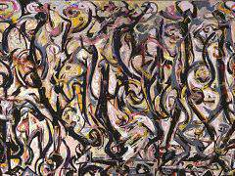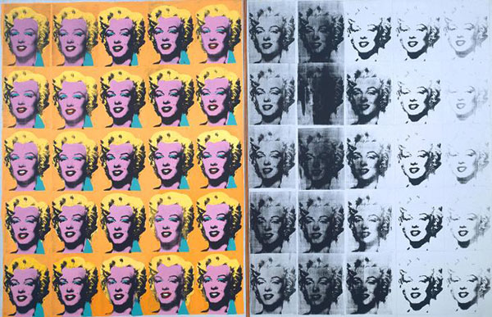

**Jackson Pollock**

**Andy Warhol**

***Feminine Mystique***

**By:** [**Betty Friedan**](https://www.goodreads.com/author/show/21798.Betty_Friedan)

Friedan was asked to conduct a survey of her former Smith College classmates for their 15th anniversary reunion; the results, in which she found that many of them were unhappy with their lives as housewives, prompted her to begin research for *The Feminine Mystique*, conducting interviews with other suburban housewives, as well as researching psychology, media, and advertising. She originally intended to publish an article on the topic, not a book, but no magazine would publish her article.

***Catcher in the Rye***

**By: JD Salinger**

a 1951 novel by J. D. Salinger. A controversial novel originally published for adults, it has since become popular with adolescent readers for its themes of teenage angst and alienation It has been translated into almost all of the world's major languages. Around 250,000 copies are sold each year with total sales of more than 65 million books. The novel's protagonist Holden Caulfield has become an icon for teenage rebellion. The novel also deals with complex issues of identity, belonging, loss, and connection.

***On the Road***

**By: Jack Kerouac**

On the Road is a novel by American writer Jack Kerouac, based on the travels of Kerouac and his friends across America. It is considered a defining work of the postwar Beat and Counterculture generations, with its protagonists living life against a backdrop of jazz, poetry, and drug use. The idea for On the Road, Kerouac's second novel, was formed during the late 1940s in a series of notebooks, and then typed out on a continuous reel of paper during three weeks in April 1951

What is the difference between nonconformity by choice and circumstance? Who do you think was impacted the *most* by the push for social conformity in the 1950’s?

*“Each suburban wife struggles with it alone. As she made the beds, shopped for groceries, matched slipcover material, ate peanut butter sandwiches with her children, chauffeured Cub Scouts and Brownies, lay beside her husband at night- she was afraid to ask even of herself the silent question-- 'Is this all?”*

*“I’m standing on the edge of some crazy cliff. What I have to do, I have to catch everybody if they start to go over the cliff—I mean if they’re running and they don’t look where they’re going I have to come out from somewhere and catch them. That’s all I’d do all day. I’d just be the catcher in the rye and all.”*

**How do these three pieces of literature reflect the non-conformist culture of the 1950s?**

*“It's funny. All you have to do is say something nobody understands and they'll do practically anything you want them to.”*

*“I was surprised, as always, be how easy the act of leaving was, and how good it felt. The world was suddenly rich with possibility.”*

*“The best teacher is experience and not through someone's distorted point of view”*