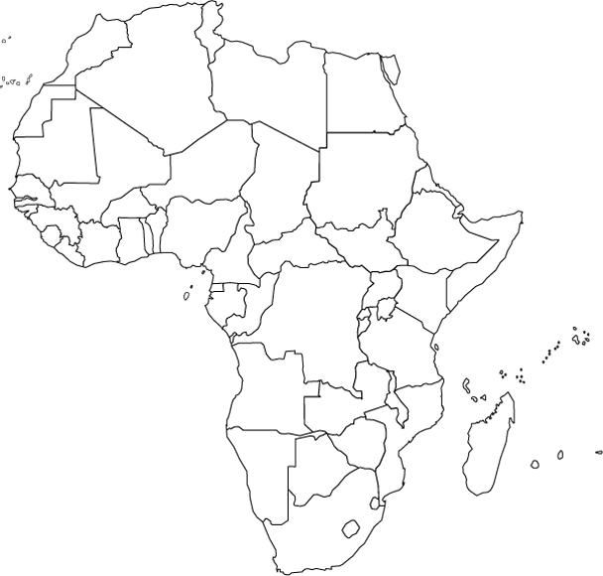

Political Map of Africa
Please label all the countries of Africa.
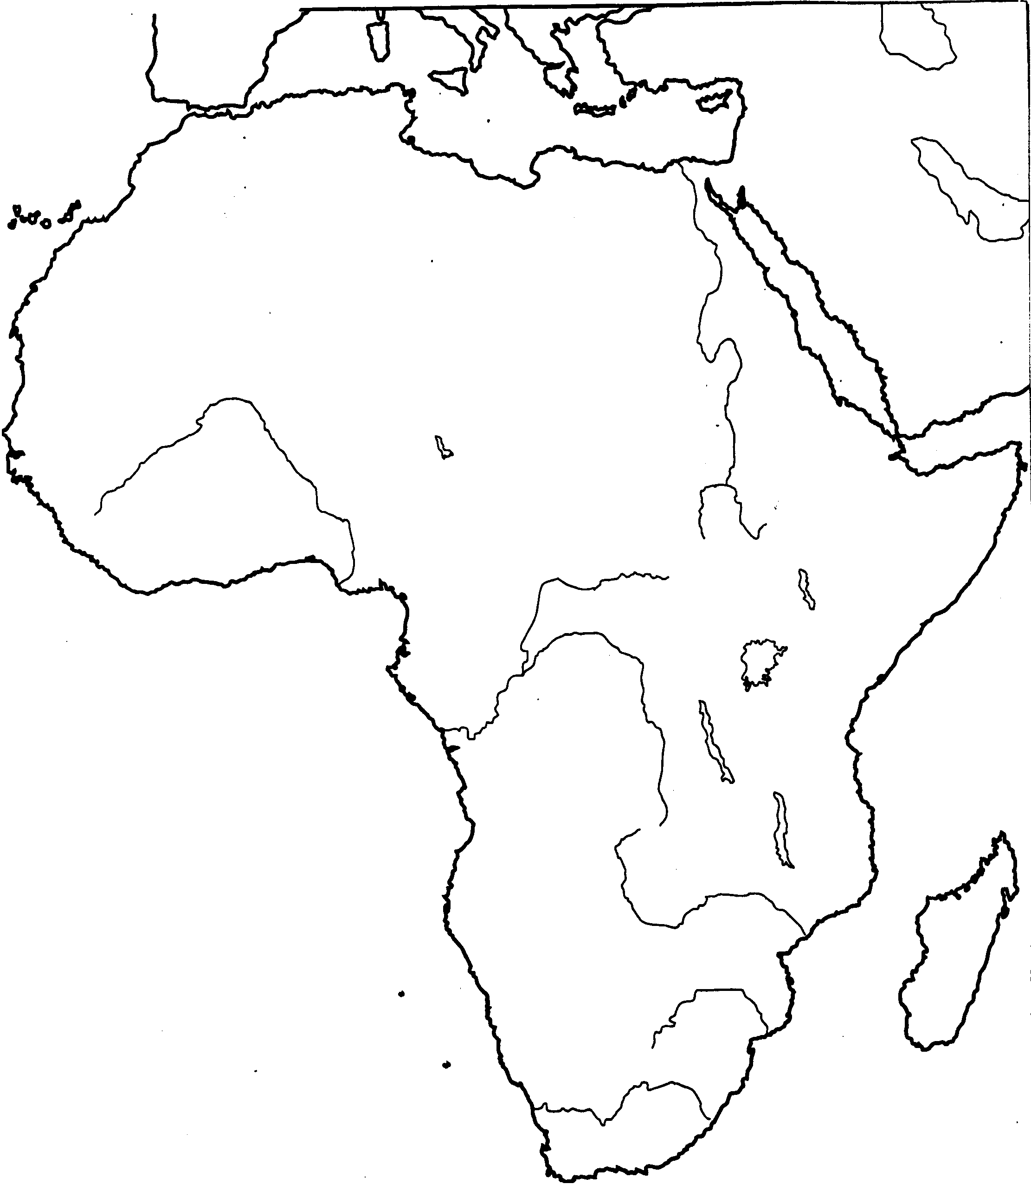

Physical Geography
Please label the following:
- Nile River, Mt. Kilimanjaro, Lake Victoria, Lake Malawi, Lake Tanganyika, Sahara Desert, Kalahari Desert, Atlas Mountains, Congo River, Orange River, Zambezi River, Niger River, Ubangi River Mozambique Channel, Cape of Good Hope, Congo Basin, Great Rift Valley, Ethiopian Highlands, Mediterranean Sea, Atlantic Ocean, Gulf of Guinea, Sahel

