2. Ideas That Shaped Colonials Views on Government
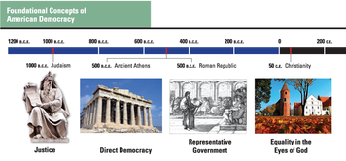
The Declaration of Independence and the U.S. Constitution are among the most important political documents ever written. Their authors—men like Thomas Jefferson, John Adams, Benjamin Franklin, and James Madison—were among the most creative political thinkers of their time. But these men did not operate in an ideological vacuum. They were influenced by political ideas and ethical teachings that had roots in ancient times. These ideas and beliefs helped shape political views in the colonies and eventually gave rise to the American system of government.

The Religious and Classical Roots of Colonial Ideas About Government
Colonial thinkers were strongly influenced by the ethical ideas shared by the Judeo-Christian religious traditions. Their notion of justice, for example, was rooted in the principles of ancient Judaism, which stressed that people should seek to create a just society based on respect for the law.
They were also influenced by the concept of natural law. This was the belief that there exists, beyond the framework of human laws, a universal set of moral principles that can be applied to any culture or system of justice. According to the Christian philosopher Thomas Aquinas, people could discover these natural laws using both reason and their inborn sense of right and wrong. A human law that violated natural law, many colonists believed, was unjust and should be changed.
The creators of the Declaration of Independence used natural law to explain why the 13 colonies needed to rebel against the British. The Declaration states that “the Laws of Nature and of Nature's God” empowered the colonies to seek a “separate and equal station” from an oppressive government.
Colonial leaders also looked to the past for ideas about how to govern a society. From the Greek city-state of Athens came the tradition of direct democracy, or decision making by all citizens. Direct democracy took root in New England's town meetings, where citizens gathered to discuss and solve their local problems.
From the Roman Republic came the idea of republicanism, or representative government, which refers to decision making by officials elected from the citizenry. Many colonists also admired the Roman idea of civic virtue. They understood this to mean a willingness to serve one's country.
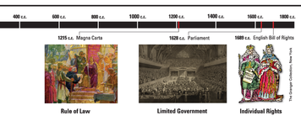

The English Roots of American Government
The traditions and principles of English government also had a great influence on political views in the colonies. Although the colonists eventually rebelled against British rule, they had great respect for English common law and Britain's constitutional system. This system was based on a set of laws, customs, and practices that limited the powers of government and guaranteed the people certain basic rights. In fact, one reason the colonists rebelled was to secure the “rights of Englishmen” that they believed had been denied to them.
This tradition of English rights was based on three key documents: the Magna Carta, the Petition of Right, and the English Bill of Rights. The first—the Magna Carta, or “Great Charter”—was signed by King John in 1215. A charter is a written grant of authority. The Magna Carta was forced on the king by English nobles, who were angered by the heavy taxes and arbitrary rules imposed by their monarch.
The Magna Carta defined the rights and duties of English nobles and set limits on the monarch's power. For example, the charter stated that the monarch could not make special demands for money from his nobles without their consent. In time, this provision was used to support the argument that no tax should be levied by a monarch without Parliament's consent.
In addition, the Magna Carta established the principle of the rule of law. One article of the charter says that the king cannot sell, deny, or delay justice. Another states that “no free man shall be seized or imprisoned . . . except by the lawful judgment of his equals or by the law of the land.” The Magna Carta made it clear that all people, including the monarch, were subject to the rule of law.
Over the next few centuries, English monarchs often ignored or defied the principles set down in the Magna Carta. Royal taxation and abuse of power sparked ongoing struggles with Parliament. In 1628, Parliament tried to limit the power of King Charles I by passing a law called the Petition of Right. This second key document prohibited arbitrary arrests and the quartering of troops in private homes without the owners' consent. The Petition of Right underscored the principle of limited government by affirming that the king's power was not absolute.
The third key document, the English Bill of Rights, was passed by Parliament in 1689. At the time, Britain was just emerging from years of political turmoil and civil war. Parliament offered the throne to a new king and queen, William and Mary of Orange, but insisted that they accept the Bill of Rights as a condition of their rule.
The English Bill of Rights reaffirmed the principle of individual rights established in the Magna Carta and the Petition of Right. New individual rights guaranteed to British subjects included the right to petition the king, the right to bear arms, and freedom from cruel and unusual punishments. Other provisions included the right to trial by jury and to hold elections without royal interference. The English Bill of Rights also finally established the power of Parliament over the monarchy. The king could not levy taxes or maintain an army during peacetime, for example, without Parliament's consent.
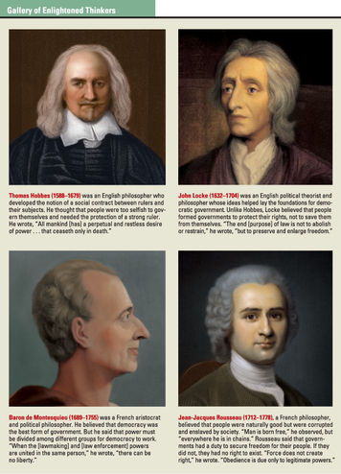

The Contributions of English Enlightenment Thinkers
Colonial leaders were also strongly influenced by the ideas of the Enlightenment, an intellectual movement of the 1600s and 1700s. Enlightenment thinkers stressed the value of science and reason, not only for studying the natural world, but also for improving human society and government.
Two key figures of the early Enlightenment were the English philosophers Thomas Hobbes and John Locke. Both men helped develop the social-contract theory, which stated that people in society agreed to give up some of their freedom to governments in exchange for security and order.
Hobbes first introduced the idea that government was the result of a social contract between people and their rulers. In his book Leviathan, published in 1651, Hobbes theorized that people had once lived in a state of nature. This state was an imaginary time before any governments had been formed. People living in this mythical time were free to do as they pleased, without laws or other restraints. Because some people used their freedom to prey on others, however, the result was a war of “every man against every man.” For most people, Hobbes wrote, life in this time was “solitary, poor, nasty, brutish, and short.”
To escape from this misery, Hobbes argued, people entered into a social contract. This contract obliged the people to give up some of their freedom by agreeing to obey an absolute ruler. In exchange for this pledge of obedience, the ruler agreed to bring peace and order to society. Hobbes was obviously not promoting democracy in his writing, but his social-contract theory did lay the groundwork for the idea that government was formed by the consent of the people.
Locke took the idea of a social contract between the people and their rulers a step further. In his Second Treatise on Government, published in 1689, Locke argued that in the state of nature, all people were equal and enjoyed certain natural rights, or rights that all people have by virtue of being human. These rights include the right to life itself, to liberty, and to the ownership of property produced or gained through one's own labors.
Locke agreed with Hobbes that it was in people's self-interest to enter into a social contract that exchanged some of their freedom for the protection of government. He went on to argue that this social contract was provisional. If a ruler failed to protect the people's life, liberty, and property, then the people had a right to overthrow that ruler and establish a new government.
The idea that the purpose of government was to protect the rights of the people exerted a powerful influence on colonial thinkers. Eventually this idea would be used to help justify the American Revolution.

Influences of French Enlightenment Thinkers
Two French thinkers also made major contributions to political thought during the Enlightenment. One was Charles-Louis de Secondat, more commonly known as Baron de Montesquieu. The other was Jean-Jacques Rousseau.
Montesquieu is most famous for his book The Spirit of Laws, published in 1748. In this book, Montesquieu argued that governments should be organized in a way that prevents any one person or group from dominating or oppressing others. This argument led him to propose a three-branch system of government—executive, legislative, and judicial— with separate functions for each branch. In this system, each branch would act to limit the power of the other branches. This principle of separation of powers was so admired by Americans that they applied it to their colonial governments.
Rousseau was a Swiss-born philosopher who spent much of his life in France. In his book The Social Contract, Rousseau extended the social contract still further. He added the idea that for a government formed by a social contract to have legitimacy, it must be based on popular sovereignty, or the general will of the people. He wrote,
The heart of the idea of the social contract may be stated simply: Each of us places his person and authority under the supreme direction of the general will, and the group receives each individual as an indivisible part of the whole.
—Jean-Jacques Rousseau, The Social Contract, 1762
Rousseau further argued that if a government acted contrary to the general will, it had broken the social contract and should be dissolved. Many colonial leaders agreed with Rousseau that government should be based on the will of the people. Thomas Paine, whose book Common Sense helped push the colonies toward independence, was particularly influenced by Rousseau's writings.

