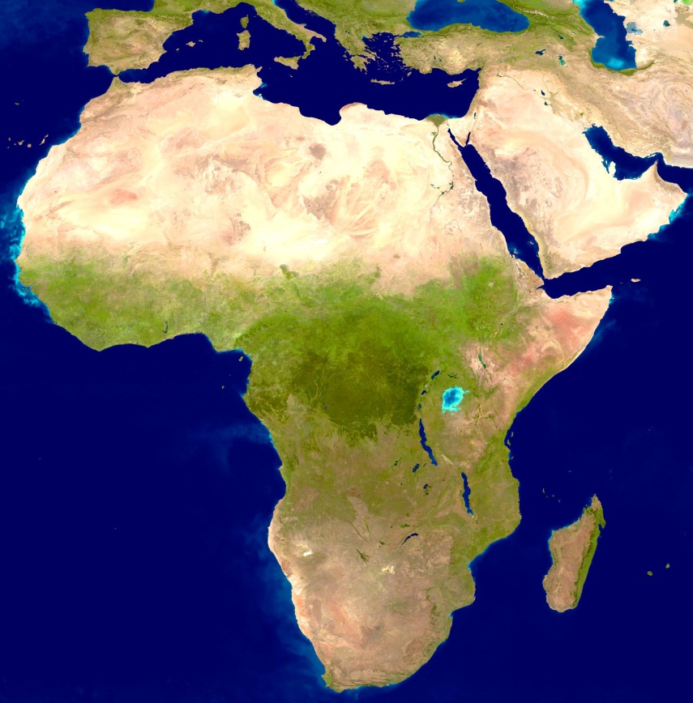
The Shape of Africa
By Jared Diamond

Ask someone to tell you quickly what they associate with Africa, and the answers you'll get will probably range from "cradle of humankind" and "big animals" to "poverty" and "civil war." How did one continent come to embody such extremes?
Geography and history go a long way toward providing the explanations. Geographically, Africa resembles a bulging sandwich. The sole continent to span both the north and south temperate zones, it has a thick tropical core lying between one thin temperate zone in the north and another in the south. That simple geographic reality explains a great deal about Africa today.
As to its human history, this is the place where some seven million years ago the evolutionary lines of apes and humans diverged. It remained the only continent our ancestors inhabited until about 100,000 years ago. At that point, our African ancestors underwent some further profound change. Whether it was the development of complex speech or something else, such as a change in brain wiring, we aren't sure. Whatever it was, it transformed those early Homo sapiens into what paleoanthropologists call "behaviorally modern" Homo sapiens. Those people, probably with brains similar to our own, expanded into Europe and Asia.
In effect, Africans enjoyed not just one but three huge head starts over humans on other continents. That makes Africa's economic struggles today, compared with the successes of other continents, particularly puzzling. It's the opposite of what one would expect from the runner first off the block. Here again geography and history give us answers.
It turns out that the rules of the competitive race among the world's humans changed radically about 10,000 years ago, with the origins of agriculture. The domestication of wild plants and animals meant our ancestors could grow their own food instead of having to hunt or gather it in the wild. That allowed people to settle in permanent villages, to increase their populations, and to feed specialists—inventors, soldiers, and kings—who did not produce food. With domestication came other advances, including the first metal tools, writing, and state societies.
The problem is that only a tiny minority of wild plants and animals lend themselves to domestication, and those few are concentrated in about half a dozen parts of the world. As every schoolchild learns, the world's earliest and most productive farming arose in the Fertile Crescent of southwestern Asia, where wheat, barley, sheep, cattle, and goats were domesticated. While those plants and animals spread east and west in Eurasia, in Africa they were stopped by the continent's north-south orientation. Crops and livestock tend to spread much more slowly from north to south than from east to west, because different latitudes require adaptation to different climates, seasons, day lengths, and diseases. Africa's own native plant species—sorghum, oil palm, coffee, millets, and yams—weren't domesticated until thousands of years after Asia and Europe had agriculture. And Africa's geography kept oil palm, yams, and other crops of equatorial Africa from spreading into southern Africa's temperate zone. While South Africa today boasts the continent's richest agricultural lands, the crops grown there are mostly northern temperate crops, such as wheat and grapes, brought directly on ships by European colonists. Those same crops never succeeded in spreading south through the thick tropical core of Africa.
The domesticated sheep and cattle of Fertile Crescent origins took about 5,000 years to spread from the Mediterranean down to the southern tip of Africa. The continent's own native animals—with the exception of guinea fowl and possibly donkeys and one breed of cattle—proved impossible to domesticate. History might have turned out differently if African armies, fed by barnyard-giraffe meat and backed by waves of cavalry mounted on huge rhinos, had swept into Europe to overrun its lamb-fed soldiers mounted on puny horses. That this didn't happen was no fault of the Africans; it was because of the kinds of wild animals available to them.
Ironically, the long human presence in Africa is probably the reason the continent's species of big animals survive today. African animals co-evolved with humans for millions of years, as human hunting prowess gradually progressed from the rudimentary skills of our early ancestors. That gave the animals time to learn a healthy fear of man, and with it a healthy avoidance of human hunters. In contrast, North and South America and Australia were settled by humans only within the last tens of thousands of years. To the misfortune of the big animals of those continents, the first humans they encountered were already fully modern people, with modern brains and hunting skills. Most of those animals—woolly mammoths, saber-toothed cats, and in Australia marsupials as big as rhinoceroses—disappeared soon after humans arrived. Entire species may have been exterminated before they had time to learn to beware of hunters.
Unfortunately the long human presence in Africa also encouraged something else to thrive—diseases. The continent has a well-deserved reputation for having spawned some of our nastiest ones: malaria, yellow fever, East African sleeping sickness, and AIDS. These and many other human illnesses arose when microbes causing disease in animals crossed species lines to evolve into a human disease. For a microbe already adapted to one species to adapt to another can be difficult and require a lot of evolutionary time. Much more time has been available in Africa, cradle of humankind, than in any other part of the planet. That's half the answer to Africa's disease burden; the other half is that the animal species most closely related to humans—those whose microbes required the least adaptation to jump species—are the African great apes and monkeys.
Africa continues to be shaped in other ways by its long history and its geography. Of mainland Africa's ten richest countries—the only ones with annual per person gross domestic products over $3,500—nine lie partly or entirely within its temperate zones: Egypt, Libya, Tunisia, Algeria, and Morocco in the north; and Swaziland, South Africa, Botswana, and Namibia in the south. Gabon is Africa's only tropical country to make the list. In addition, nearly a third of the countries of mainland Africa (15 out of 47) are landlocked, and the only African river navigable from the ocean for long distances inland is the Nile. Since waterways provide the cheapest way to transport heavy goods, geography again thwarts Africa's progress.
All these factors can lead to the question: Is the continent, or at least its big tropical core, doomed eternally to wars, poverty, and devastating diseases? I'd answer: Absolutely not. On my own visits to Africa, I've been struck by how harmoniously ethnic groups live together in many countries—far better than they do in many other parts of the globe. Tensions arise in Africa, as they do elsewhere, when people see no other way out of poverty except to fight their neighbors for dwindling resources. But many areas of Africa have an abundance of resources: The rivers of central Africa are great generators of hydroelectric power; the big animals are a major source of ecotourism revenue in eastern and southern Africa; and the forests in the wetter regions, if managed and logged sustainably, would be renewable and lucrative sources of income.
As for Africa's health problems, they can be greatly alleviated with the right planning and funding. Within the past half century several formerly poor countries in Asia recognized that tropical diseases were a major drain on their economies. By investing in public health measures, they have successfully curbed those diseases, and the increased health of their people has led to far healthier economies. Within Africa itself, some international mining and oil companies have been funding successful public health programs throughout their business areas because they realized that protecting the health of their workers was an excellent business investment for them.
What's the best case for Africa's future? If the continent can overcome its health problems and the corruption that plagues many of its governments and institutions, then it could take advantage of today's globalized, technological world in much the same way that China and India are now doing. Technology could give Africa the connections that its geography, particularly its rivers, long denied it. Nearly half of all African countries are English speaking, an advantage in trade relations, and an educated, English-speaking workforce could well attract service jobs to many African countries.
If Africa is to head into a bright future, outside investment will continue to be needed, at least for a time. The cost of perpetual aid to or military intervention in Africa is thousands of times more expensive than solving health problems and supporting local development, thereby heading off conflicts. Not only Africans but the rest of us will be healthier and safer if Africa's nations increasingly take their places as peaceful and prospering members of the world community.

