10 Stages of Genocide
In 1966, Dr. Gregory Stanton, a founding member of Genocide watch, presented a document called “The 8 stages of Genocide”. In 2012, the stages have been expand to 10 including discrimination and persecution. It is important to note, that while the stages are in a list format, they are not intended to be linear and can happen simultaneously. Keep this in mind when you conduct your own research so that you do not overlook a stage because you believe it is contingent upon a previous stage happening first. There is however, a predictable progression of the stages, as jumping straight to extermination would not have worked - you must first have majority acceptance of the other stages.

Please zoom in to view the details/characteristics of each stage:
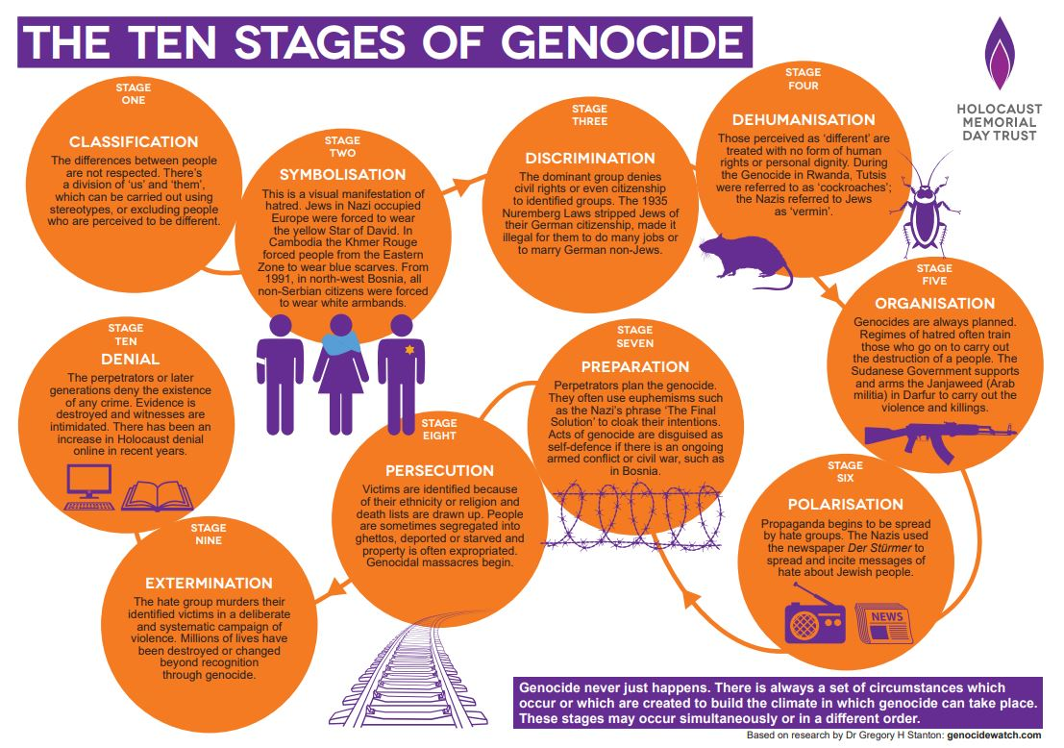

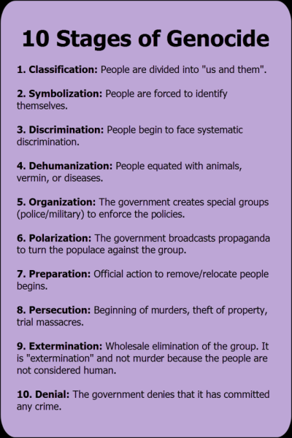

Stages of Genocide Worksheet:

After reading the primary source, begin filling out this worksheet. Add quotes and citations for evidence, as well as notes about how the quote demonstrates the stage.
Stage | Quotes  “Quote” | Notes (Analysis- how the quotation demonstrates the stage)
Classification
Symbolization
Discrimination
Dehumanization
Organization
Polarization
Preparation
Persecution
Extermination
Denial

