Exporting a Works Cited from Noodle Tools
- Log on to Noodle Tools
- Click on the project “Civics research outline” or whatever you named your project
- Click on “Sources” at the top middle of the page
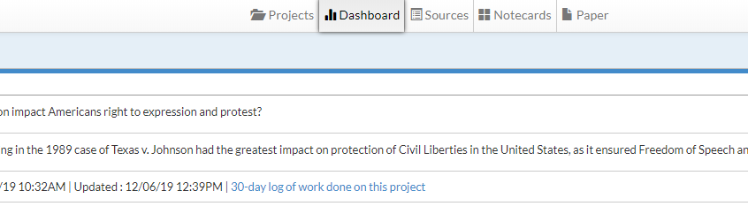
- Then click on the button “Print/Export” at the top left corner of the page
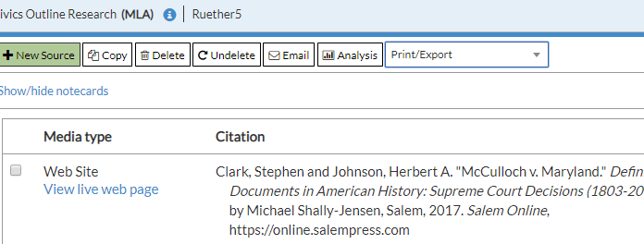
- Select how you want your sources to be exported, e.g. word doc or google doc
- The file will download and appear in the bottom left of your screen
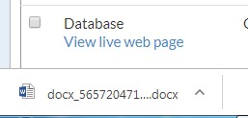
- Open and save your file as your “Works Cited”
- Attach to the end of your outline

